Week7Lab – 10 pts

Pre-lab questions

1. Create an inheritance hierarchy (class names only) for Currency that consists of several values of bills and several values of coins.

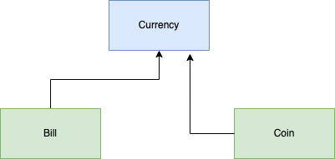

Choose one of the following to develop into a program that will use polymorphism. For the sake of time, you must have a minimum of four classes in your coded solution (1 has main), however, your inheritance hierarchy may be as large as you like. Once chosen, do the following:

Understand the problem (restate in your own words, make any assumptions clear):  
  
Inheritance hierarchy (class names only) with arrows showing the relationships:  
  
UML diagrams of the classes you will code, including the one with main:  
  
Pseudocode of any non-trivial methods in each class (no pseudocode needed for basic setters and getters or no args constructors):  
  
Name of files (.java) submitted:  
  
Explanation of how you made use of polymorphism in your solution:

Musical Instruments

Represent musical instruments in a class hierarchy. Think about what various instruments have in common when planning the hierarchy. For this lab it is OK to just use Strings to represent the sounds an instrument makes. For example, a Drum could print “boom” and a guitar could print “strum”. Create a collection of various instruments and use polymorphism to print the appropriate sound for each.

I need to develop a way to organize various musical instruments and represent them in a class hierarchy. Each instrument has its own type (brass, percussion, strings, woodwind), which I will use to represent the child elements in the hierarchy. Polymorphism will be tested by creating an ArrayList of Instruments ,adding multiple types into it, and then printing the sound and string representation of each one..

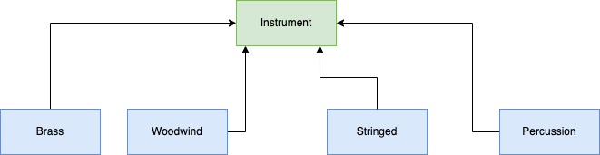

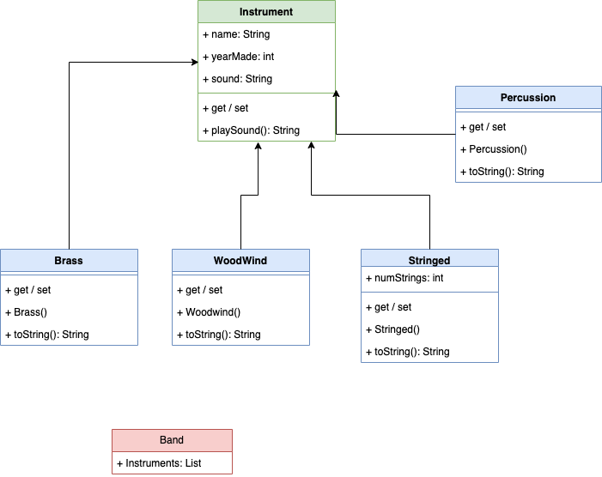

There aren’t really any non-trivial methods in this program. The playSound method is really just a getter for the instrument’s sound.

**Files submitted:** Percussion.java, Instrument.java. Brass.java, WoodWind.java, Stringed.java, Band.java

Marine Life

Lots of different things live under the sea. Represent a selection of them in a class hierarchy. Think about what they have in common when planning the hierarchy. For this lab it is OK to give each of them a “Catch Phrase” they say when called. For simplicity, you can write this in the toString() method. Create a collection of various marine life and use polymorphism to print the catch phrase for each thing is the list.

Games Again

Choose a game genre such as fantasy or space and brainstorm several enemies or bad guys for a game in that genre. Represent these in a class hierarchy. Think about what they have in common and how they differ. For this lab it is Ok to give each of them an attack type and damage value that is randomly generated within a given range. The attack type should be unique to each class of enemy. Create a collection of enemies and use polymorphism to print out the attack and damage for each.